Homework #4
(Module 4: Voltage Control Devices)

Question 1: Which of the following statements is not correct?
3) Voltage drop is only caused by resistance.
Question 2: If over a given period of time a customer has a minimum voltage of 116.3V and a maximum voltage of 121.7V, what is the percent regulation for that customer?
3) 4.4%
Question 3: For the one line drawing, and associated phasor diagram, which phasor diagram most accurately represents the addition of a shunt capacitor at the node V_{R}? Assume that I_{C} is the current injected by the shunt capacitor and that the load has a lagging power factor.
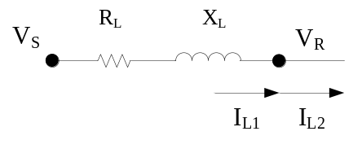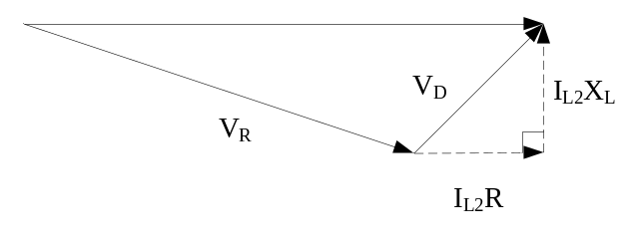

2) Phasor diagram 2:
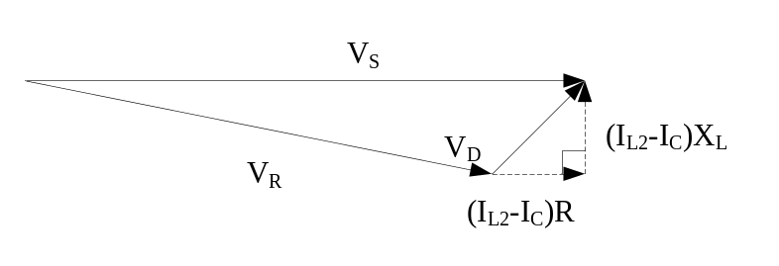

Question 4: Assuming a standard voltage regulator, +/- 16 steps, on a 12.47 kV system, how much will the output voltage at the regulator terminals change if the tap positions are increased by 13 taps?
2) 488V
Question 5: Assuming a 450KVAR capacitor bank is operated in VAR control, what would be an appropriate dead-band?
- 100kVAR
Question 6: Given the ZIP model below, what would be the difference in real and reactive power draw between 123.0V and 116.5V? Assume a nominal energy consumption of 183.4W and 43.77VAR.
Z% : 60% I%:20% P%:20%
Z_{θ}, 20°, I_{θ},-30°,P_{θ} a -15°
4) ΔP=18.5W ΔQ=5.5VAR
Question 7: Which statement best describes the capabilities of the traditional ZIP model?
- It is able the capture real and reactive power values, but it is time-invariant and cannot accurately reflect energy consumption.
Question 8: Given the plot below, what is the best approximation of voltage regulation for each phase?
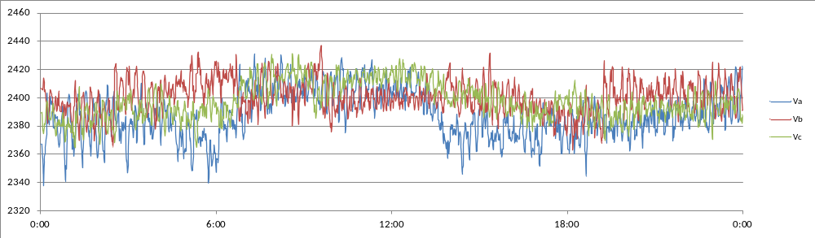
2) Phase A:3.8% Phase B:3.0% Phase C:2.7%
Question 9: What is the most accurate statement about the power plot below?
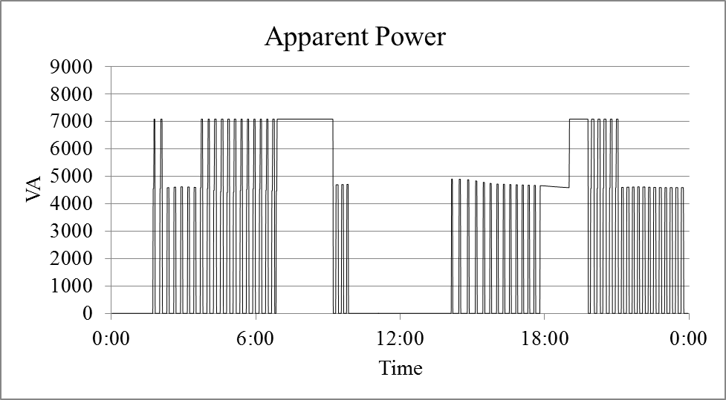
3) The plot is of a single device with multiple operational states.
Question 10: Which of the following factors does not affect the energy consumption of a single family residence?
- Size of the secondary transformer.

